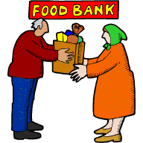
St. Vincent de Paul 2020
Can-a-Week Church Calendar
Please clip and keep in a handy location!

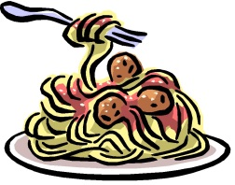
St. Vincent de Paul Food Locker provides food to those in need in our community. In 2019, we provided much needed food assistance to over 6,200 hungry people in our area. By your generous support of our Can-a-Week program, you help stock the shelves of our parish food locker. Parish families are asked to bring ONE food item to mass each week (please, no glass containers). Please remember to bring one Can-a-Week to help feed those in need in our area. Thank you!

January  5 ……………………………… Canned Fruit  12…… ……………………… Refried Beans  19……………………… Canned Tomatoes  26 ………………………………Canned Soup | February  2…………………………… Boxed crackers  9 ………………………… Top Ramen Soup  16…………………… Canned Vegetables  23 …………………………… Canned Soup | March  1 ……………………… Boxed Pasta Meal  8 ………………………………………………Tuna  15 …………………………… Canned Fruit  22 ………………………… Refried Beans  29 …………………… Canned Tomatoes

April  5 …………………… Canned Vegetables  12 …………………………… Canned Fruit  19……………………………… Canned Soup  26 ……………………… Boxed Crackers | May  3 ……………… Tuna or Peanut Butter 10 …………………… Boxed Pasta Meal  17……………………… Canned Tomatoes  24 ………………………… Refried beans 31 …………………………Boxed Crackers | June  7 ………………………… Top Ramen Soup  14 …………………………… Canned Fruit 21 ………………… Canned Vegetables  28 …………………………… Canned Soup

July  5 …………………………… Refried Beans  12………………Tuna or Peanut Butter  19 …………………… Canned Tomatoes  26 ………………………Top Ramen Soup | August  2………………………………… Canned Fruit 9 …………………………… Refried beans  16………………… Canned Vegetables  23…………………………… Canned Soup | September  6 ……………………… Canned Tomatoes  13 ……………Tuna or Peanut Butter  20……………………… Boxed Crackers  27 …………………… Top Ramen Soup

October  4………………………………Refried beans  11 ………………… Boxed Pasta Meals 18 ………………… Canned Vegetables  25…………………………… Canned Soup | November  1 ……………………………… Canned Fruit 8 ……………… Tuna or Peanut Butter  15 ………………………… Canned Olives  22 ……………… Boxed stuffing mix  29 ………………………… Boxed Candy | December  6 ……………… Canned Fruit Cocktail 13 ……………… Canned Green Beans  20…………………… Canned Vegetables  27 ……………………… Boxed Crackers  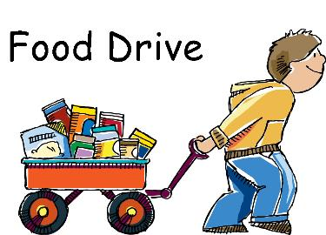

THANK YOU FOR YOUR CONTINUING SUPPORT THROUGHOUT THE YEAR.

