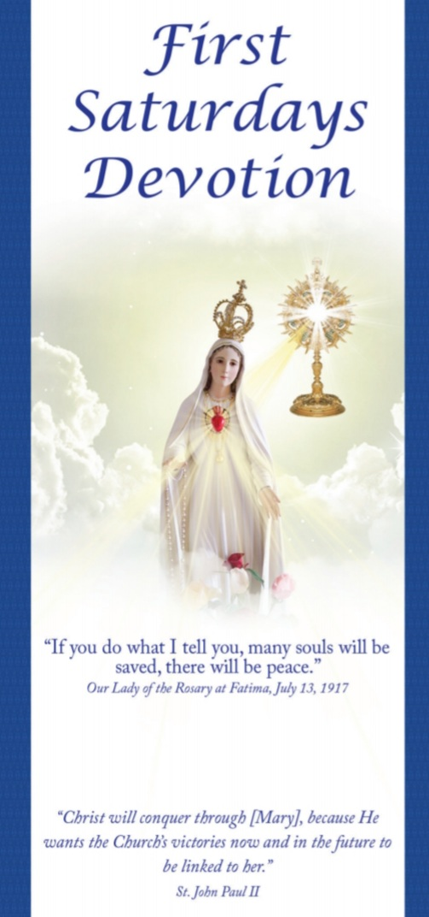**Listen and Respond to Our Lady’s explicit call to us.**

**St Isidore’s Parish has a First Saturday Devotion.**

**Prayers begin at 7am.**

**Rosary starts around 7:15am.**

**Mass at 8am.**

**15 Minute Meditation on Mysteries of the Rosary – immediately after Mass.**

**Answer Heaven’s call to Save souls! Check it out! Both Jesus and Our Lady** explicitly ask us to console and have compassion on the Heart of His Mother by making reparation to her Immaculate Heart.

Our Lady said that to save souls from going to hell, **God wishes to establish in the world devotion to her Immaculate Heart.** Our Lady said that ***if***we do what she tells us **many souls will be saved and a period of peace will** **be given to the world.**

On December 10, 1925, Our Lady made a second promise and also told us how to practice the *First Saturday*s devotion. Our Lady promises to assist at the hour of death, with all the graces necessary for salvation all those who fulfill four conditions, each with the intention of making reparation to her Immaculate Heart. To obtain the promises of Our Lady, we need to do this on five consecutive first Saturdays.

The conversion of Russia, and the world, will take place once we fulfill Our Lady’s request for the Communion of Reparation on the *First Saturdays* (*First Saturday*s Devotion). **We, the People need to do our part to fulfill the First Saturdays** **to help bring about this sanctification and conversion of not only Russia but the whole world.**

This December 10, 1925 is the 100th Anniversary of Our Lady asking Lucia, one of the three Fatima children to tell the world about the First Saturdays and the promises for those who fulfil what Our Lady asked for. Listen to Heaven’s Call! For more information, come to First Saturday Mass; literature is available. Or call Cathy: 530-755-1536.